**CASE STUDY**

## **INPUT:**

CREATE DATABASE university;

USE university;

CREATE TABLE CAMPUS(

campus_name VARCHAR(20) PRIMARY KEY,

campus_add VARCHAR(50),

distance int,

bus_no VARCHAR(50)

);

CREATE TABLE CLUB(

club_name VARCHAR(50) PRIMARY KEY,

campus_name VARCHAR(50) NOT NULL,

club_bui VARCHAR(20),

club_pno int,

FOREIGN KEY(campus_name) REFERENCES CAMPUS(campus_name)

);

CREATE TABLE SPORT(

sport_name VARCHAR(50) PRIMARY KEY,

club_name VARCHAR(50),

FOREIGN KEY(club_name) REFERENCES CLUB(club_name)

);

CREATE TABLE FACULTY(

fac_name VARCHAR(50) PRIMARY KEY,

dean_name VARCHAR(100),

fac_build VARCHAR(20)

);

CREATE TABLE SCHOOL(

scl_name VARCHAR(50) PRIMARY KEY,

fac_name VARCHAR(20),

campus_name VARCHAR(50),

scl_build VARCHAR(50),

FOREIGN KEY (fac_name) REFERENCES FACULTY(fac_name),

FOREIGN KEY (campus_name) REFERENCES CAMPUS(campus_name)

);

CREATE TABLE COMMITTEE(

com_title VARCHAR(50) PRIMARY KEY,

fac_name VARCHAR(20) ,

meeting_frequency VARCHAR(50),

FOREIGN KEY (fac_name) REFERENCES FACULTY(fac_name)

);

CREATE TABLE LECTURER(

staff_id INT PRIMARY KEY,

scl_name VARCHAR(50),

sup_id INT ,

lec_name VARCHAR(20),

lec_title VARCHAR(20),

off_room VARCHAR(20),

FOREIGN KEY (scl_name) REFERENCES SCHOOL(scl_name)

);

USE UNIVERSITY;

CREATE TABLE COMMITTEE_LECTURER(

staff_id INT,

com_title VARCHAR(50),

fac_name VARCHAR(50),

FOREIGN KEY (staff_id) references LECTURER (staff_id),

FOREIGN KEY (com_title) references COMMITTEE (com_title),

FOREIGN KEY (fac_name) references FACULTY (fac_name)

);

CREATE TABLE PROGRAMME (

pro_code CHAR(10) PRIMARY KEY,

scl_name VARCHAR(50),

pro_title VARCHAR(50),

pro_level VARCHAR(50),

pro_length VARCHAR(50),

FOREIGN KEY (pro_code) REFERENCES SCHOOL(scl_name)

);

CREATE TABLE STUDENT(

stu_id INT PRIMARY KEY,

pro_code CHAR(10),

stu_name VARCHAR(50),

stu_birthday date,

year_enrolled INT,

FOREIGN KEY (pro_code) REFERENCES PROGRAMME (pro_code)

);

CREATE TABLE COURSE(

cou_code CHAR(10) PRIMARY KEY,

pro_code CHAR(10),

cou_title VARCHAR(20),

FOREIGN KEY (pro_code) REFERENCES PROGRAMME (pro_code)

);

CREATE TABLE LECTURER_COURSE(

staff_id INT,

cou_code CHAR(10),

FOREIGN KEY(staff_id) REFERENCES LECTURER(staff_id),

FOREIGN KEY(cou_code) REFERENCES COURSE(cou_code)

);

CREATE TABLE PRE_COURSE(

cou_code CHAR(10),

pre_cou CHAR(10) NOT NULL REFERENCES PRE_COURSE(cou_code),

FOREIGN KEY (cou_code) REFERENCES COURSE (cou_code)

-- FOREIGN KEY (pre_cou) REFERENCES PRE_COURSE(pre_cou)

);

CREATE TABLE COU_STUDENT(

cou_code CHAR(10),

stu_id INT,

year_taken INT,

sem_taken INT,

grade_awarded CHAR(10),

FOREIGN KEY (cou_code) REFERENCES COURSE(cou_code),

FOREIGN KEY (stu_id) REFERENCES STUDENT(stu_id)

**OUTPUT:**

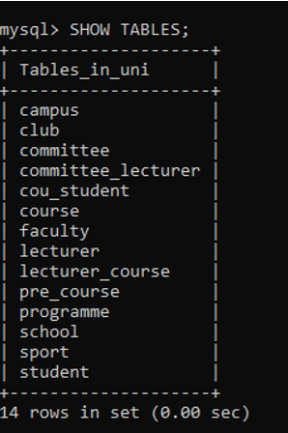

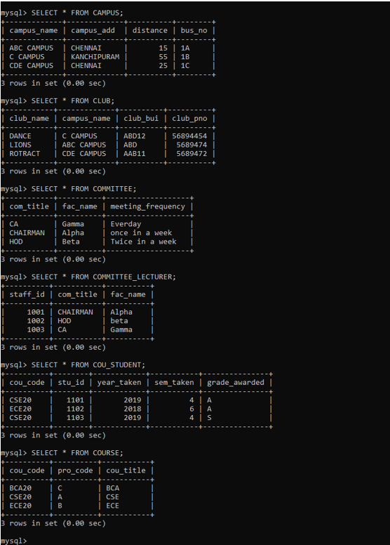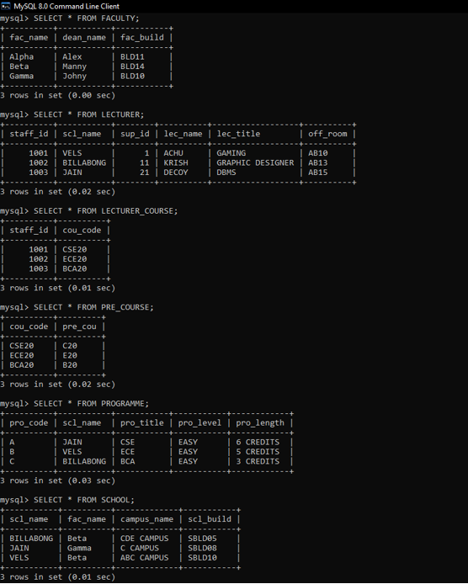

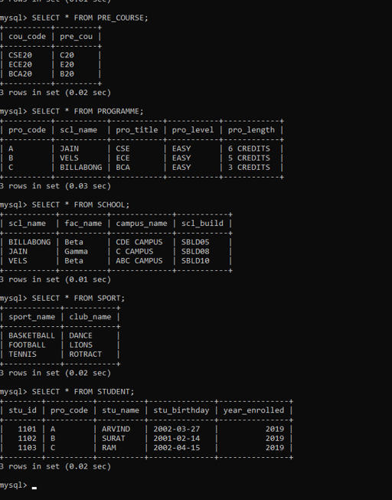

**QUERIES:**



